**List we have work last week**

1. We have updated bootstrap version for latest screen width 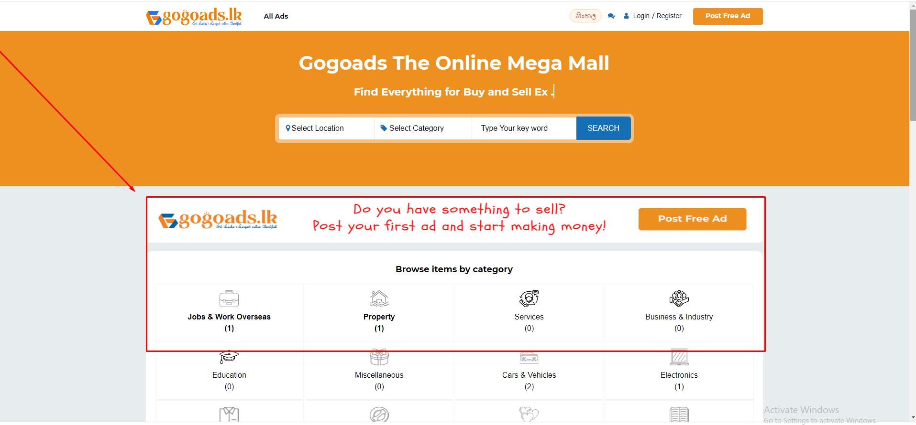
2. All categories will be shown here 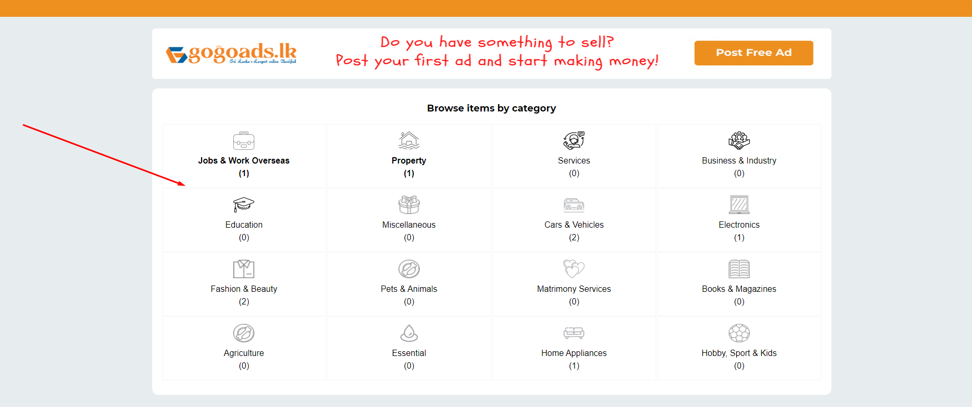
3. Language on entire website 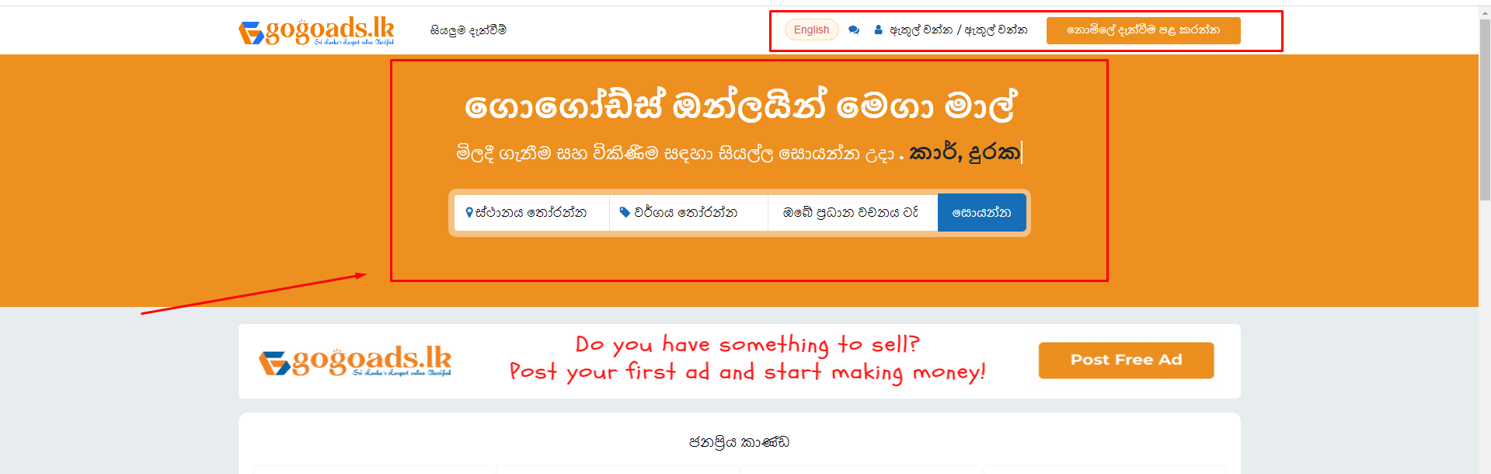
4. Standard image processing system so that we can avoid image stretch if user give high size image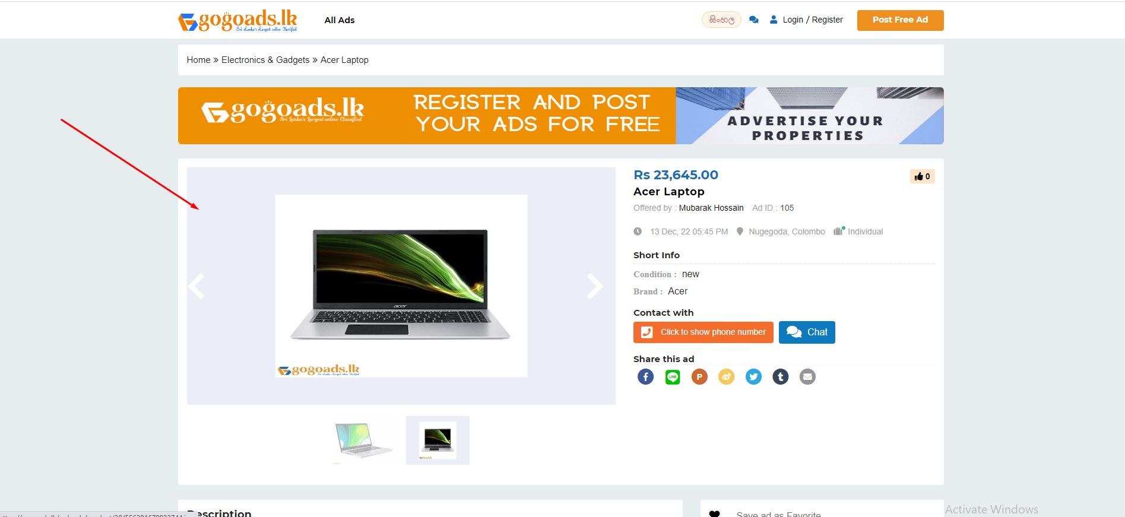
5. Professional image preview 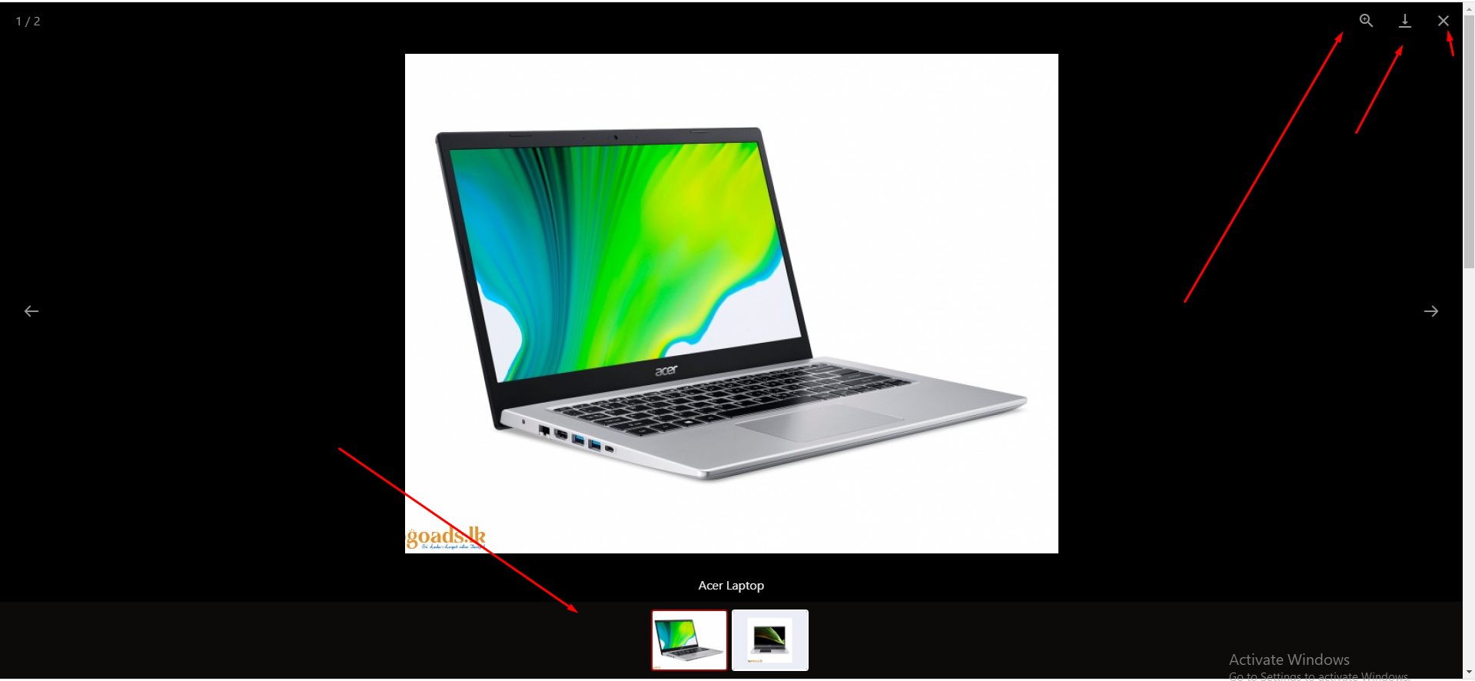
6. Updated user dashboard with new strategy 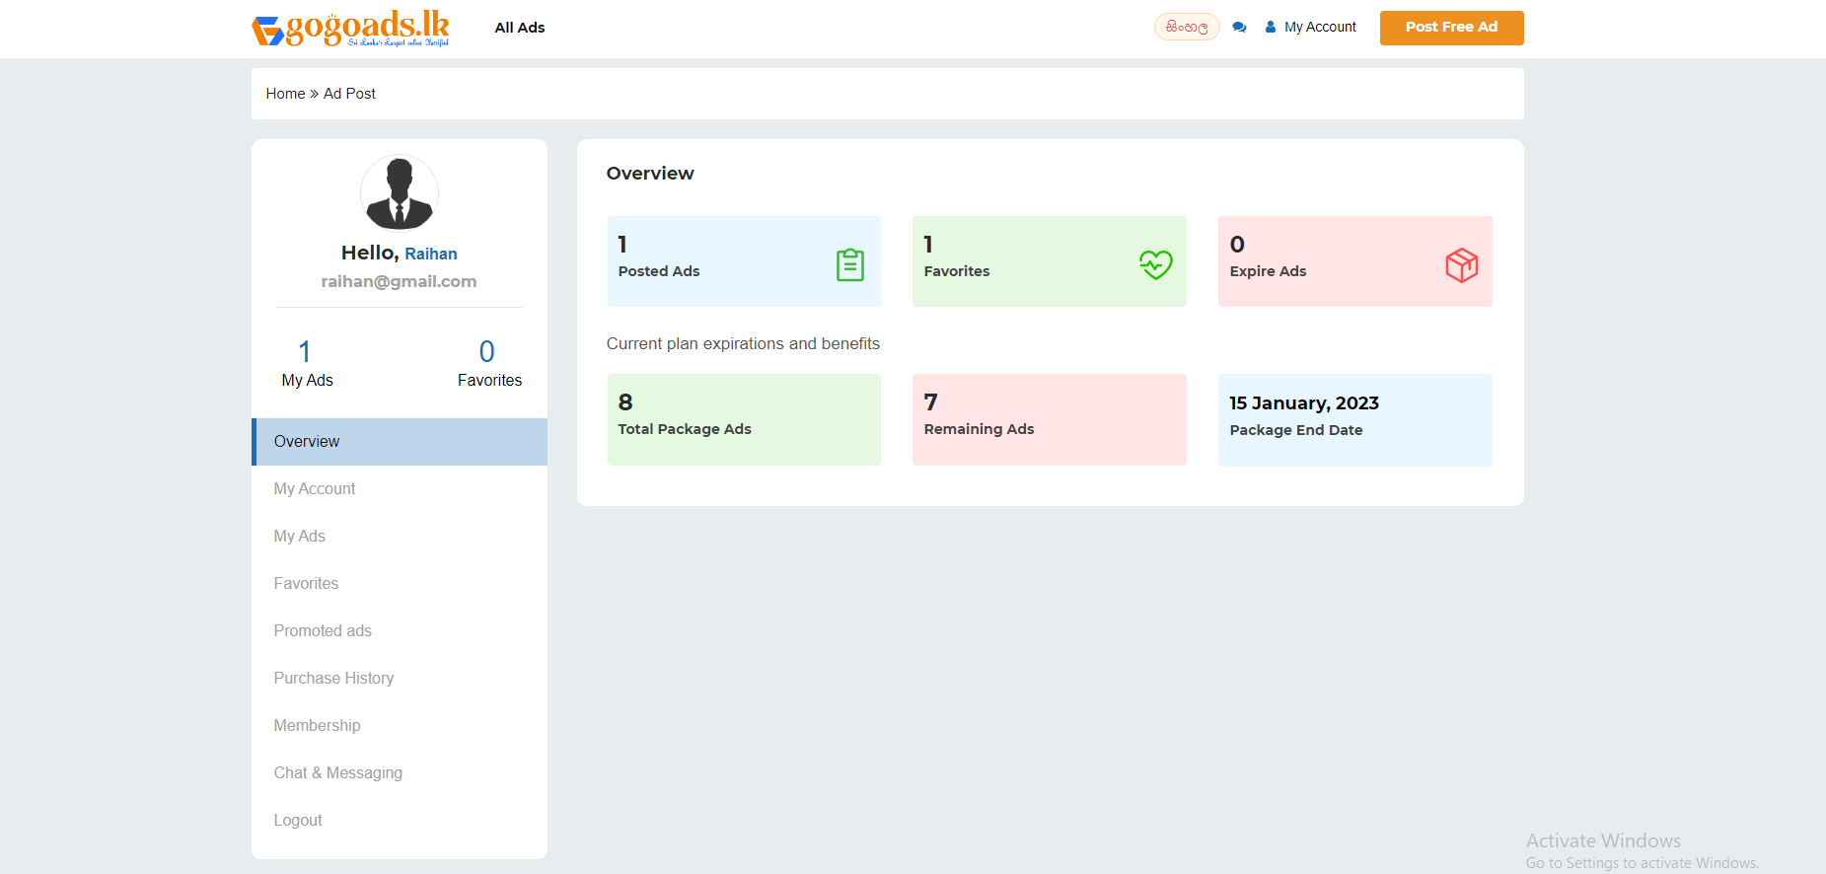
7. Updated billing and invoicing page 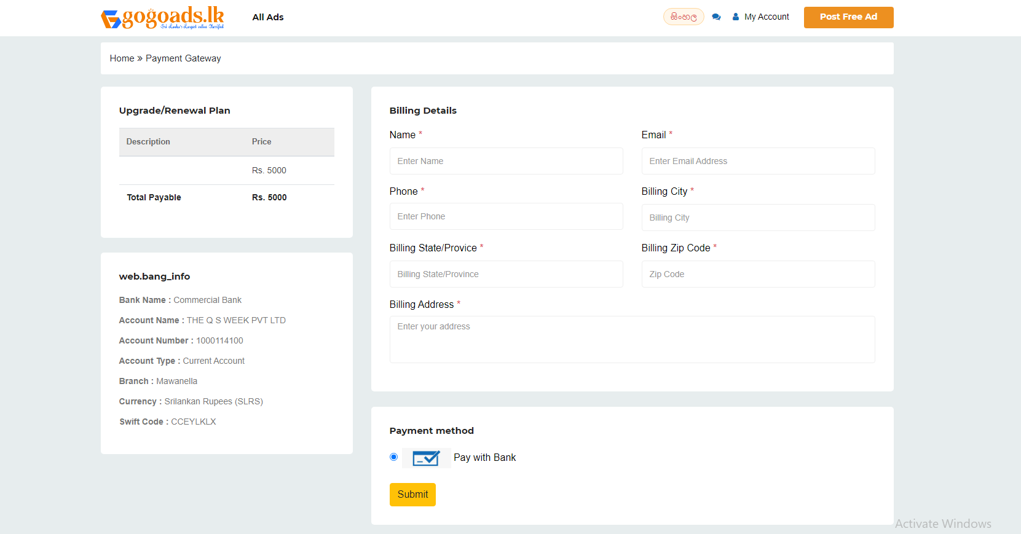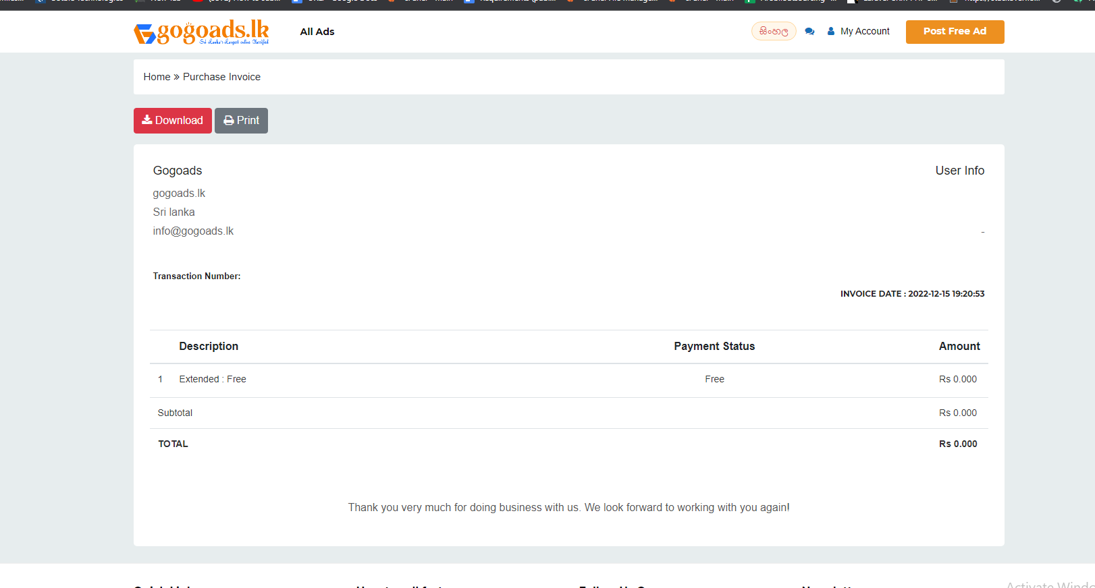
8. Shop page also is updated 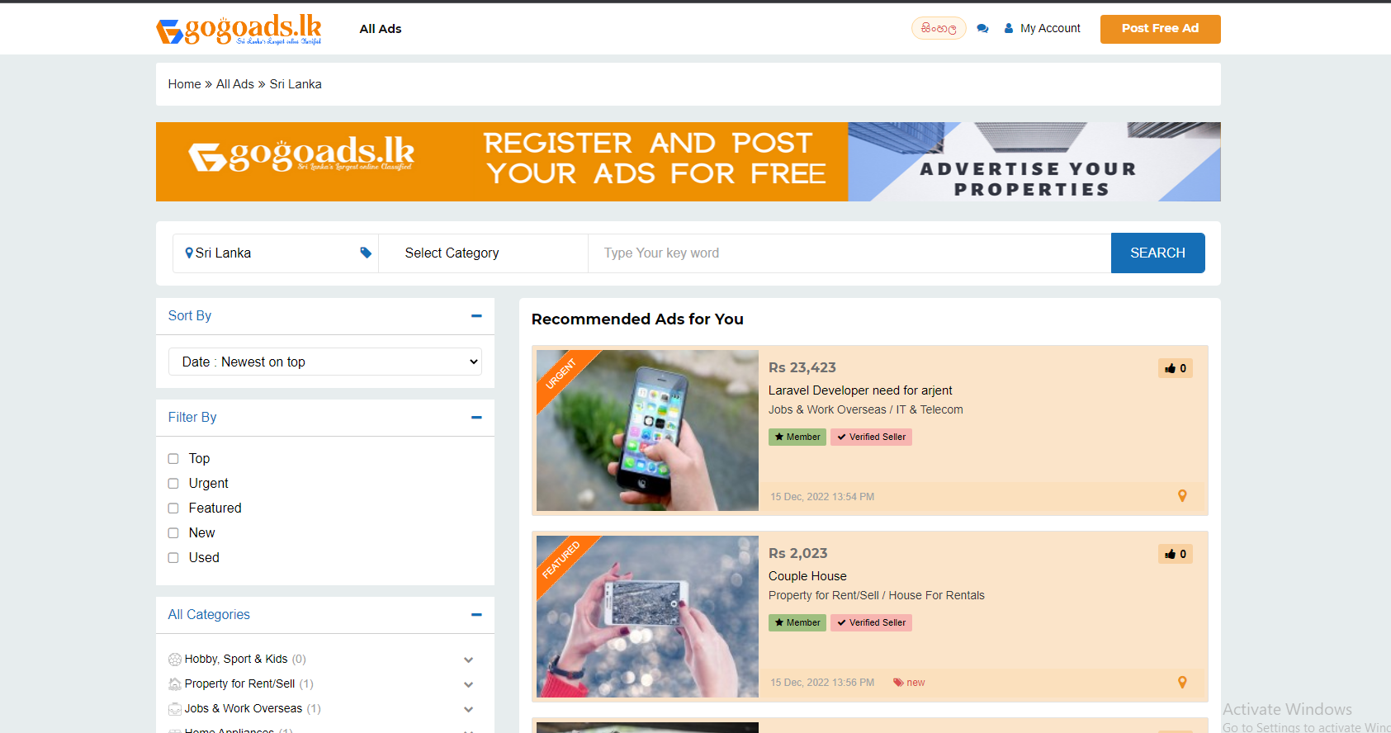
9. From admin panel you will able to update site information 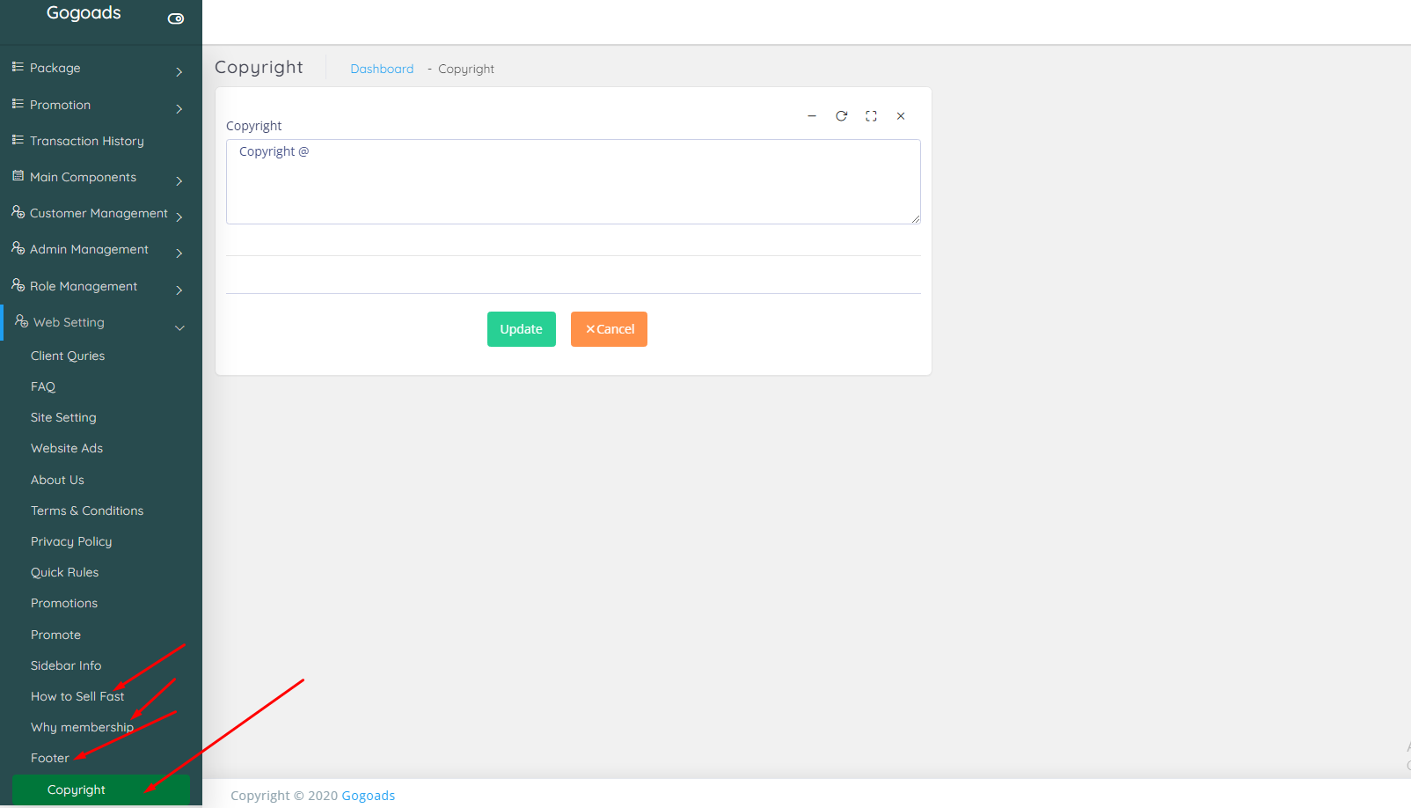
10. Area will appear after city choose and initially area will not show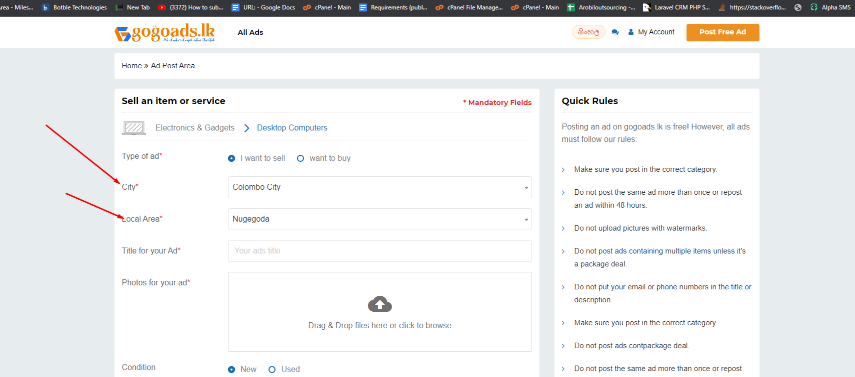
11. Pricing menus add Graphical user interface, application, website

    Description automatically generated
12. I have given all location entry Graphical user interface, application

    Description automatically generated
13. All categories and subcategories Graphical user interface, application

    Description automatically generated